**EXPERIMENT-1**

**AIM: Design a web page that demonstrate the formatting tags**

**SOURCE CODE:-**

<!DOCTYPE html>  
<html>  
    <head>  
          <title>HTML Tables</title>  
    </head>  
    <body>  
<h1>Physical Tags</h1>  
        <i>Bapatla Engineering College</i><br>  
 <b>Bapatla Engineering College</b><br>  
 <u>Bapatla Engineering College</u><br>  
 <small>Bapatla Engineering College</small><br>  
 <big>Bapatla Engineering College</big><br>  
 BEC <sub>Bapatla Engineering College</sub><br>  
 BEC<sup>Bapatla Engineering College</sup>  
 <h1>Logical Tags</h1>  
  <p><abbr title="Hyper text markup language">HTML</abbr></p><br>  
 <p><dfn title="is used to create webpages">HTML</abbr></p><br>  
 <p>BTech branches IT,CSE,ECE,EEE,EIE<ins>CS,DS</ins></p>  
 <p>IT,CSE,ECE,EEE<del>EIE</del>CS,DS</P><br>  
 <p><mark>HTML</mark>is used to create webpages</p><br>  
<p>HTML having three sections<strong>elements&attributes,tags,doctype</strong></p><b r>  
 <p>HTML having three sections<q>elements&attributes,tags,doctype</q></p><br>  
 <p>HTML having three sections<blockquote>elements&attributes,tags,doctype</blockquot e>elements are used to create webpages</p><br>  
 <p><em>html</em>  
 <p><kbd>Enter</kbd>key to execute the application</P><br>  
 <bdodir="rtl">HTML</bdo><br>  
 <bdodir="rtr">HTML</bdo><br>  
 <code>  
 &lt;!DOCTYPE &gt;  
 </code></h1>  
</body>

</html

**OUTPUT:-**

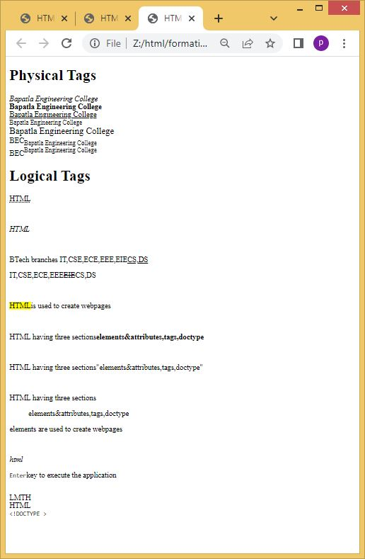**Aim:Design a webpage that demonstrate the representing types of lists**

**Source Code:**

<!DOCTYPE html>  
 <html>  
<body>  
<h2>An Unordered HTML List</h2>  
<ul>  
<li>coffee</li>  
<li>tea</li>  
<li>Milk</li>  
</ul>  
<h2>An ordered HTML List</h2>  
<ol>  
<li>Coffee</li>  
<li>Tea</li>  
<li>milk</li>  
</ol>  
<h2>An description HTML List</h2>  
<dl>  
<dt>Coffee</dt>  
<dd>Black hot drink</dd>  
<dt>Milk</dt>  
<dd>white cold drink</dd>

</body>

</html>

**OUTPUT:-**

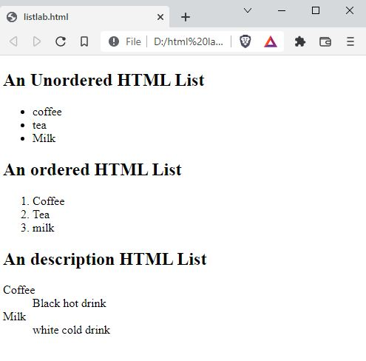

**Aim: Design a webpage that demonstrate the TimeTable**

**Source Code:**

<!DOCTYPE html>

<html>

<head>

<title>TIME TABLE</title>

</head>

<body>

<div style="width:10%;float:left">

<pre>

<imgsrc="img1.png" width="100" height="100"

</pre>

</div>

<h3><center>Bapatla Engineering College::Bapatla</h3>

<h4><center>(Autonoumus)</h4>

<center><h4>Department of Information Technology</h4>

<h4 style="color:red">Class Time Tablefor the <u><mark>A.Y 2021-22,IV Semester</mark></u></h4>

<hr>

<pre>

<h3>w.e.f: 28-03-20222 class: II B.Tech,IT Section: A Room No: RPLH-03</h3>

</pre>

<table border-collapse:collapse" border="10">

<col style="background-color:orange">

<tr style="background-color:orange">

<th>Day</pre></th>

<th>7:30-<pre>8:20</th>

<th>8:20-<pre>9:10</th>

<th>9:10-<pre>10:00</th>

<throwspan="8"><pre>B</pre><pre>R</pre><pre>E</pre><pre> A </pre><pre>K <pre></pre></th>

<th>10:30-<pre>11:20</th>

<th>12:10</th>

<th>12:10-<pre>1:00</th>

</tr>

<tr>

<td>Mon</td>

<td>PEHV</td>

<td>Python programming</td>

<td>DBMS</td>

<td>P&S</td>

<td>DAA</td>

<td>WT</td>

</tr>

<tr>

<td>Tue</th>

<td colspan="3"><pre><-WT/RDBMS-></pre></td>

<td>DBMS</td>

<td>Python programming</td>

<td>wt</td>

</tr>

<tr>

<td>Wed</td>

<td>DBMS</td>

<td>P&S</td>

<td>DAA</td>

<td colspan="3"><PRE><-RDBMS/Python proglab -></PRE></td>

</tr>

<tr>

<td>Thu</td>

<td>PEHV</td>

<td>Python programming</td>

<td>DBMS</td>

<td>P&S</td>

<td>DAA</td>

<td>WT</td>

</tr>

<tr>

<td>Fri</td>

<td colspan="3"><PRE><-Python prog lab/Wt lab-></PRE></td>

<td>WT</td>

<td>DAA</td>

<td>DBMS</td>

</tr>

<tr>

<td>Sat</td>

<td>DBMS</td>

<td>DAA</td>

<td>p&s</td>

<td>PEHV</td>

<td>PEHV</td>

<td style=background-color:green> Mentoring</td>

</tr>

</table>

<pre>

<big><mark>Section Coordinator:Mr.k.SureshKumar,Asst.professor</b>

</pre>

<table>

<tr style="background-color:orange">

<td>sub:code</td>

<td>sub name</td>

<td>faculty name</td>

<td>sub code</td>

<td>sub name</td>

<td>faculty name</td>

</tr>

<tr>

<td>20IT401</td>

<td>p&s</td>

<td>Mr.pothuraju</td>

<td>20It461</td>

<td>Mr.sk.Mabhasa</td>

<td>Wtlab</td>

</tr>

<tr>

<td>20IT402</td>

<td>wt</td>

<td>Mr.sk.Mabhasa</td>

<td>20It402</td>

<td>RDBMS</td>

<td>Mr.Ravikumar</td>

</tr>

<tr>

<td>20IT403</td>

<td>DBMS</td>

<td>Mr.Ravikumar</td>

<td>20It403</td>

<td>python lab</td>

<td>Mr.sureshkumar</td>

</tr>

<tr>

<td>20IT404</td>

<td>DAA</td>

<td>Mr.sivaramprasad</td>

<td></td>

<td></td>

<td></td>

</tr>

<tr>

<td>MO12</td>

<td>PEHV</td>

<td>Dr.k.srinivasarao</td>

<td></td>

<td></td>

<td></td>

</tr>

</table>

<hr>

<pre>

<h3>w.e.f: 28-03-20222 class: II B.Tech,IT Section: A Room No: RPLH-03</h3>

</pre>

<table style="border-collapse:collapse" border="10">

<col style="background-color:orange">

<tr style="background-color:orange">

<th>Time <pre>Day</th>

<th>7:30-<pre>8:20</th>

<th>8:20-<pre>9:10</th>

<th>9:10-<pre>10:00</th>

<throwspan="7"><pre> B</pre><pre> R </pre><pre>E</pre><pre> A </pre><pre>K </pre></th>

<th>10:30-<pre>11:20</th>

<th>11:20-<pre>12:10</th>

<th>12:10-<pre>1:00</th>

</tr>

<tr>

<td>Mon</th>

<td colspan="3"><-WT/RDBMS-></td>

<td>DBMS</td>

<td>Python programming</td>

<td>wt</td>

</tr>

<tr>

<td>Tues</td>

<td>P&S</td>

<td>Python programming</td>

<td>DAA</td>

<td>PEHV</td>

<td>DBMS</td>

<td>WT</td>

</tr>

<tr>

<td>Wed</td>

<td>PEHV</td>

<td>Python programming</td>

<td>DBMS</td>

<td>P&S</td>

<td>DAA</td>

<td>WT</td>

</tr>

<tr>

<td>Thu</td>

<td>P&S</td>

<td>WT</td>

<td>DAA</td>

<td colspan="3"><PRE><-RDBMS/Python prog lab -></PRE></td>

</tr>

<tr>

<td>Wed</td>

<td>PEHV</td>

<td>Python programming</td>

<td>DBMS</td>

<td>P&S</td>

<td>DAA</td>

<td>WT</td>

</tr>

<tr>

<td>Sat</td>

<td>DAA</td>

<td>DBMS</td>

<td>p&s</td>

<td>PEHV</td>

<td>WT</td>

<td style=background-color:green> Mentoring</td>

</tr>

</table>

<pre>

<big><mark>Section Coordinator:Mr.k.SureshKumar,Asst.professor</b>

</pre>

<table>

<tr style="background-color:orange">

<td>sub:code</td>

<td>sub name</td>

<td>faculty name</td>

<td>sub code</td>

<td>sub name</td>

<td>faculty name</td>

</tr>

<tr>

<td>20IT401</td>

<td>p&s</td>

<td>Mr.karunakar</td>

<td>20It461</td>

<td>Wtlab</td>

<td>Mr.sk.Mabhasa</td>

</tr>

<tr>

<td>20IT402</td>

<td>wt</td>

<td>Mr.sk.Mabhasa</td>

<td>20It402</td>

<td>RDBMS</td>

<td>Mr.Ravikumar</td>

</tr>

<tr>

<td>20IT403</td>

<td>DBMS</td>

<td>Mr.Ravikumar</td>

<td>20It403</td>

<td>python lab</td>

<td>Mr.k.Prasanth</td>

</tr>

<tr>

<td>20IT404</td>

<td>DAA</td>

<td>Mr.Ratnaprakash</td>

<td></td>

<td></td>

<td></td>

</tr>

<tr>

<td>MO12</td>

<td>PEHV</td>

<td>Dr.k.srinivasarao</td>

<td></td>

<td></td>

<td></td>

</tr>

</table><pre>

<big> HOD PRINCIPAL </big>

</pre>

</body>

</html>

**OUTPUT:-**

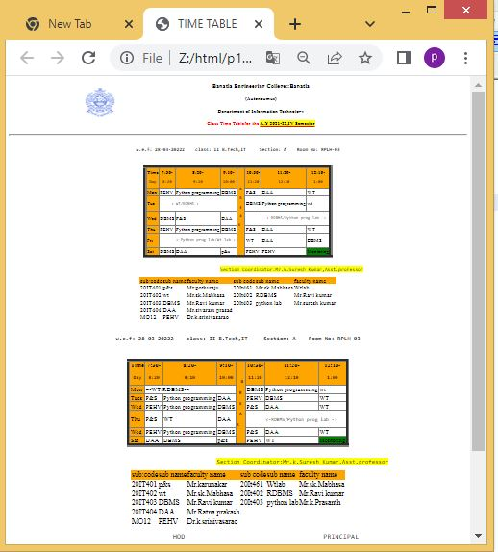

**EXPERIMENT-2**

**Aim: - Decribing internal link,external link and image as a link**

**Source Code:-**

<!DOCTYPE html>

<html>

<head>

<style>

#myheader{

background-color:lightblue;

color:black;

text:white;

padding:40px

text-align:center;

}

</style>

</head>

<body>

<a id="top">

<a href="#bottom"><img src="down.png" width="100" height="100"></a>

<p>bapatla engineering college</p>

<p>bapatla engineering college</p>

<p>bapatla engineering college</p>

<p>bapatla engineering college</p>

<p>bapatla engineering college</p>

<p>bapatla engineering college</p>

<p>bapatla engineering college</p>

<p>bapatla engineering college</p>

<p>bapatla engineering college</p>

<p>bapatla engineering college</p>

<p>bapatla engineering college</p>

<a href="#top"><img src="up2.png" width="100" height="100"></a><br>

<a id="bottom">

<a href="Z:html/p1.html">new web page</a><br>

<a href="Z:html/p6.html"> click to move bec homepage<img src="n1.jpg" width="200" height="150"</a><br>

<a href="Z:html/p2.html" target="_blank">clickhere to move different window</a><br>

<a href="Z:html/p3.html" target="_self">click here to move same window</a><br>

<a href="Z:html/p8-1.html" target="_top">click here to move same window</a>

</body>

</html>

**OUTPUT:-**

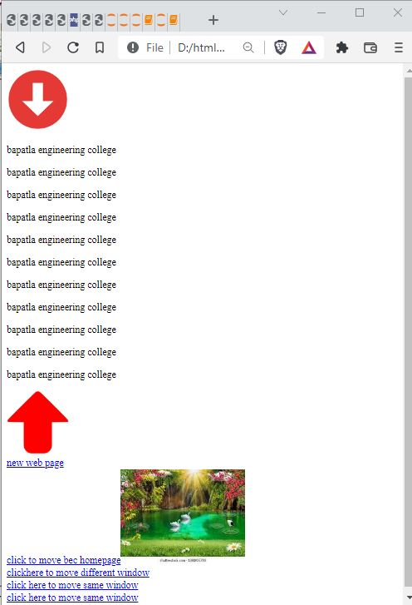

**Aim:- Design a web page that demonstrate the id using Frames**

**Source Code:-**

<!DOCTYPE html>

<html>

<head>

<title>Frames</title>

</head>

<frameset rows="20%,60%,20%" border="1">

<frame name="header" src="header.html">

<frameset cols="25%,75%">

<frame name="navigation" src="idframe.html">

<frame name="section" src="section.html">

</frameset>

<frame src="footer.html" name="footer"/>

</frameset>

</html>

**header.html**

<!DOCTYPE html>

<html>

<head>

<title>HTML Tables</title>

</head>

<body>

<h2>HEADER</h2>

</body>

</html>

**idframe.html:-**

<!DOCTYPE html>

<html>

<head>

<title>navigation</title>

</head>

<body>

<nav>

<a id="top">

<a href="#bottom"><img src="down.png" width="50" height="50"></a><br><br>

<a href="p4.html" target="section">-> inbox</a><br>

<a href="sent.html" target="section">->sent</a><br>

<a href="starred.html" target="section">-> starred</a><br>

<a href="imp.html" target="section">-> important</a><br>

<p>bapatla engineering college</p>

<p>bapatla engineering college</p>

<p>bapatla engineering college</p>

<p>bapatla engineering college</p>

<p>bapatla engineering college</p>

<p>bapatla engineering college</p>

<p>bapatla engineering college</p>

<p>bapatla engineering college</p>

<p>bapatla engineering college</p>

<a href="#top"><img src="up2.png" width="50" height="50"></a>

<a id="bottom">

</nav>

</body>

</html>

**Section.html:-**

<!DOCTYPE html>

<htmml>

<head>

<title>HTML Tables</title>

</head>

<body>

<H2>section</h2>

</body>

</html>

**Footer.html:-**

<!DOCTYPE html>

<htmml>

<head>

<title>HTML Tables</title>

</head>

<body>

<H2>footer</h2>

</body>

</html>

**OUTPUT:-**

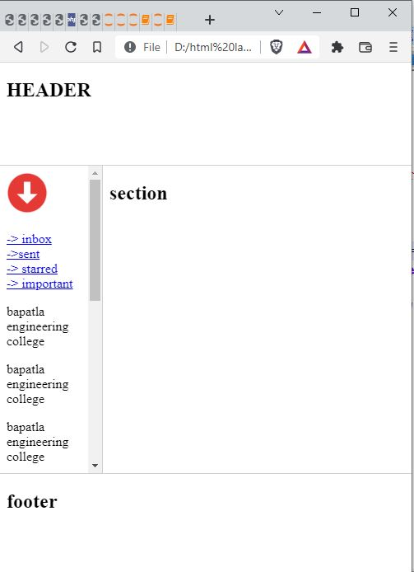

**Aim:-Design a web page that demonstrate the Image Map creation**

**Source Code:-**

<!DOCTYPE html>

<html>

<head>

<title>Image Map</title>

</head>

<body>

<h1>Image Map Creation</h1>

<img src="n4.jpeg" usemap="#school" width="400" height="379">

<map name="school">

<area shape="circle" coords="337,300,44" href="Z:html/p1.html">

<area shape="rect" coords="34,44,270,350" href="Z:html/p4.html">

</map>

</body>

</html>

**OUTPUT:-**

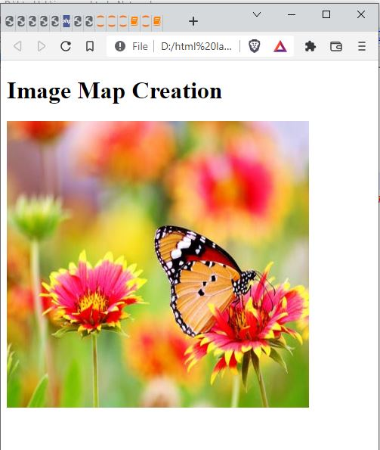

**EXPERIMENT-3**

**Aim:- Write html document to create registration form using the all the input Fields**

**Source Code:**

<!DOCTYPE html>  
<html>  
<head>  
<title>forms application</title>  
</head>  
<body style="background-color:cyan">  
<form>  
<center><table border="1px"width="1000" style="text-align:center">  
<tr>  
<td><h1>Student Registration Form</h1>  
</td>  
</tr>  
</table></center><br><br>  
<label>Name :</label>  
<input type="text" placeholder="Enter ful name" size="70"><br/><br/>  
<label>Father's Name :</label>  
<input type="text" size="70"><br/><br>  
<label>Mother's Name :</label>  
<input type="text" size="70"><br/><br>  
<label>Phone Number :</label>  
<input type="number" placeholder="017*******" size="70"><br/><br>  
<label>Email :</label>  
<input type="email" placeholder="[sample@example.com](mailto:sample@example.com)" size="70"><br/><br>  
<label>Gender : :</label>  
<input type="radio" value="Male"name="gender">Male  
<input type="radio" value="Female"name="gender">Female  
<input type="radio" value="Other"name="gender">Other<br/><br>  
<label>Date of birth</label>  
<input type="text"size="10">-  
<input type="text"size="10">-  
<input type="text"size="10">(dd-mm-yy)<br><br  
<label>Address :</label>  
<textarea rows="1"cols="100">  
Street- House-Road  
</textarea><br><br>  
<label>Blood Group: :</label>  
<select >  
<option>select</option>  
<option>A</option>  
<option>A+</option>  
<option>B</option>  
<option>B+</option>  
<option>AB-</option>  
<option>O-</option>  
<option>O+</option>  
</select><br/><br>  
<label>Department :</label>  
<label> :</label>  
<input type="radio" value="CSE"name="department">CSE  
<input type="radio" value="EEE"name="department">EEE  
<input type="radio" value="BBA"name="department">BBA<br/><br>  
<label>Course</label>  
<input type="checkbox"value="c">c  
<input type="checkbox"value="c++">c++  
<input type="checkbox"value="java">java  
<input type="checkbox"value="AI">AI  
<input type="checkbox"value="Machine learning">Machine learning  
<input type="checkbox"value="Robotics">Robotics<br><br>  
<label>Photo :</label>  
<input type="file"><br><br><br><br>  
<a href="p1.html">Submit</a>  
</body>  
</html>

**Output:**

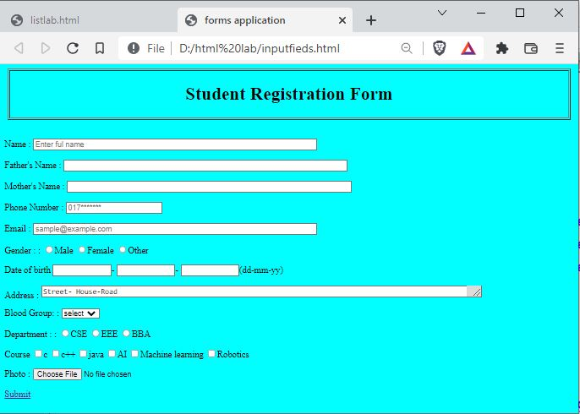

**Aim:- Write html document to create a form that demonstrate the Label,Text Area,Legend,Option,Option group,select.**

**Source Code:**

<!DOCTYPE html>

<html>

<head>

<title>fieldset Tag</title>

</head>

<body>

<form>

<h1>Registration Form</h1>

<fieldset>

<legend>Student Details</legend>

<legend>Student Name:</label><input type = "text"><br />

<label>Student Regd Number:</label><input type = "text"><br />

<label>Branch:</label><input type = "text" >

</fieldset>

<P>Enter the name of the your favorite car:</P><br>

<INPUT type="text" name="favCar" list="cars">

<DATALIST id="cars">

<OPTION value="BMW">

<OPTION value="Porsche">

<OPTION value="Audi">

<OPTION value="Ford">

<OPTION value="Ferrari">

<OPTION value="Mercedes">

</DATALIST>

Fill the Detail: <br /><br>

<textarea rows = "5" cols = "50" name = "description">

Enter your Details here

</textarea><br />

<input type = "submit" value = "submit" />

</form>

</body>

</html>

**OUTPUT:-**

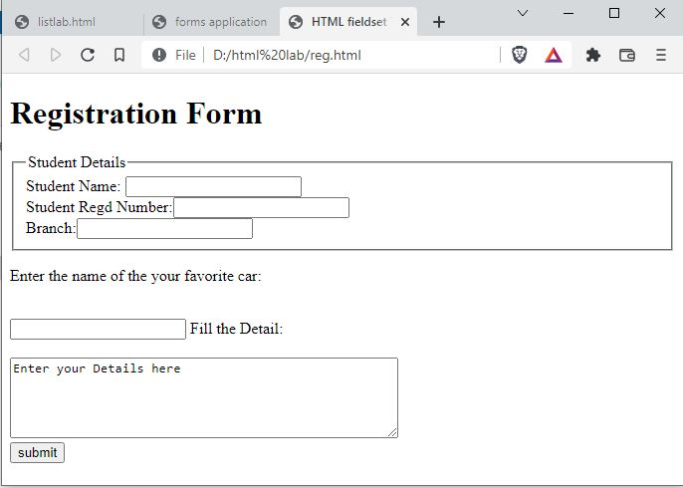

**EXPERIMENT-4**

**Aim:-** Design a web page that demonstrate the CSS inline sheet

**Source Code:**

<!DOCTYPE html>

<html>

<head>

<title>css on inline-style</title>

</head>

<body style="background-color:rgb(0,200,100);">

<h1 style="text-align:center;color:red;font-size:50px;background-color:cyan;">CSS on Inline style</h1>

<p style="padding:20px;border: 5px dotted brown;color:yellow;"><u>THE INLINE STYLE SHEET</u><BR>The inline style properties are written in a single line separated by semicolon.<br>

The properties are placed by using the style attribute inside HTML elements.</p>

<p style="font-size:18px;background-color:yellow;color:black;"><u>Advantages:</u><br>

✓ Provides highest precedence over internal and external style sheets.<br>

✓Provides an easy and quick approach to add style sheet in a web</p>

<p style="font-size-adjust:5.5;">pujitha</p>

</body>

</html>

**Output:**

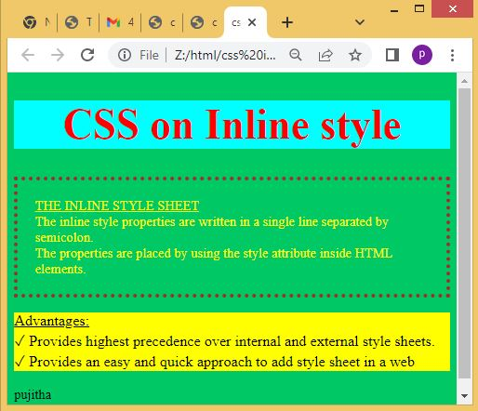

**Aim:-**Design a web page that demonstrate the CSS internal style sheet

**Source Code:**

<!DOCTYPE html>

<html>

<head>

<title>css on internal-style</title>

<style type="text/css">

*{

margin:5px;

}

#p1{

padding:1%;

font-size:50px;

border:5px solid red;

color:yellow;

background-color:pink;

text-align:center;

}

p{

font-size:30px;

color:red;

}

.p2{

margin:2%;

background-color:lightgray;

}

ol>li{

font-family:serif;

background-color:cyan;

}

li b{

color:lightgreen;

}

</style>

</head>

<body>

<h1 id="p1">Welcome to inline style sheet</h1>

<div class="p2">

<p>The Internal style sheet<br>

<ul>

<li><b>The internal style sheet is written within the HEAD element of the HTML document.</b></li>

<li> The properties are placed by using the STYLE element inside HEAD elements.</li>

<li>STYLE element having both the starting and ending tags.</li>

</ul>

<p>• Advantages:</p>

<ol>

<li>✓ Affects only the page in which they are placed.</li>

<li>✓ Allows you to change the styles of the same HTML file in which you are working.</li>

</ol>

<p>• Disadvantages:</p>

<ol>

<li>✓ Affects only the page in which they are applied.</li>

<li>✓ Increase the page load time.</li>

</ol>

</body>

**OUTPUT:-**

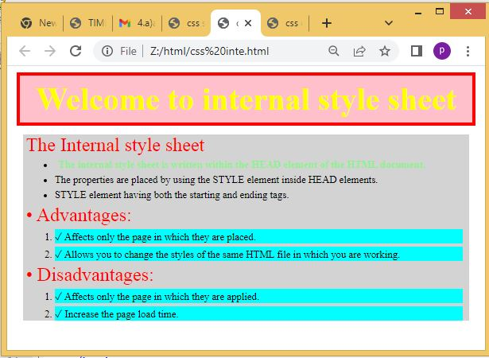

**Aim:-Design a web page that demonstrate the CSS inline sheet**

**Source Code:-**

<!DOCTYPE html>

<html>

<head>

<title>external style sheet</title>

<link rel="stylesheet" type="text/css" href="ext.css"/>

</head>

<body>

<h1>welcome to css on external style sheet</h1>

<p><u>The External style sheet</u></p>

<ul>

<li>The external style sheet is written outside of the HTML document.</li>

<li>The external style sheet was saved into a text file with .css extension.</li>

<li>The properties of external style sheet were linked to the HTML document intwo ways:</li>

</ul>

<b>1.Linking:</b>

<ul

<li>LINK element is used to link the external style sheet to HTML document.</li>

<li>The link element is an empty element</li>

</ul>

<b>2.importing:</b><br>

<ul>

<li>It allows you to accessing the style rules from another style sheet and represented by @import</li>

</ul>

<p><u>advantages:</u></p>

<ol>

<li> Affects multiple pages in which they are placed with single document.</li>

<li>Allows you to easily group your styles in a more efficient way.</li>

</ol>

<p><u>Disadvantages:</u></p>

<ol>

<li>display the time to apply the entire CSS file to the HTML document</li>

<li> Display the web page only after the entire style sheet is loaded.</li>

</ol>

</body>

</html>

**OUTPUT:-**

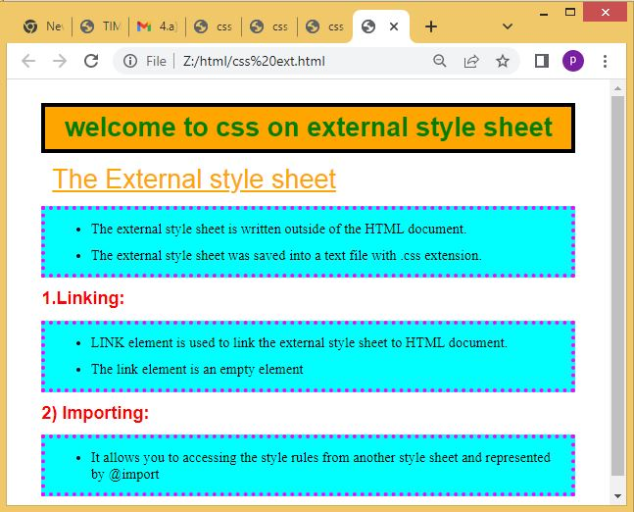

**Aim:- Design a web page that demonstrate the Query selector**

**Source Code:-**

<!DOCTYPE html>

<html>

<head>

<title>query selector</title>

<scripttype"text/javascript">

functionqueryselector(){

p=document.querySelector("#p2");

p.style.background="lightgreen";

}

functionqueryselectorall(){

p=document.querySelectorAll("p");

for(var i=0;i<p.length;i++){

p[i].style.color="pink";

}

}

</script>

</head>

<body>

<p>myparagraph</p>

<p id="p2">my paragraph 2</p>

<p>myparagraph 3</p>

<p>myparagraph 4</p>

<button onclick="queryselector()">Query selector</button>

<button onclick="queryselectorall()">Query selector All</button>

</body>

</html>

**OUTPUT:-**

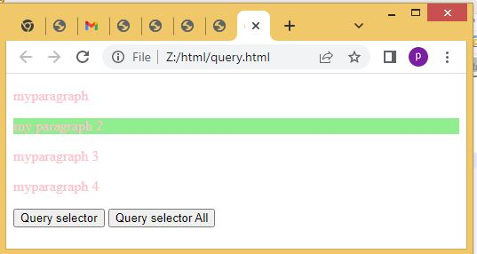

**Aim:-Design a web page that demonstrate the MouseEvents**

**SourceCode:-**

<!DOCTYPE html>

<html>

<head>

<title>mouse events</title>

<style>

#f1{

border:1px solid black;

width:200px;

height:100px;

overflow:scroll;

}

</style>

<script type="text/javascript">

functionmouseclick(){

document.getElementById("btn1").style.background="pink";

}

functionmousedbclick(){

document.getElementById("btn2").style.color="red";

}

functionmousedown(){

document.getElementById("p1").style.color="yellow";

}

functionmouseup(){

document.getElementById("p1").style.color="orange";

}

functionmousemov(e){

var x=e.clientX;

var y=e.clientY;

document.getElementById("msg").innerHTML="coord are :"+x+""+y;

}

functionmouseou(){

document.getElementById("msg").innerHTML="";

}

functionmouseove(i){

i.style.width="500px";

i.style.height="500px";

}

functionmouseout(i){

i.style.width="100px";

i.style.height="100px";

}

functionmousewheel(){

document.getElementById("p2").style.fontSize="35px";

}

</script>

</head>

<body>

<h1><center>Mouse Events</center></h1>

<button id="btn1" onclick="mouseclick()">click here</button><br><br>

<button id="btn2" ondblclick="mousedbclick()">double click here</button><br>

<p id="p1"onmousedown="mousedown()" onmouseup="mouseup()">bapatla engineering clg</p>

<imgsrc="i1.jpg"width="200"height="200" onmousemove="mousemov(event)" >

<p id="msg"></p>

<imgsrc="i2.jpg"width="200"height="200" onmouseover="mouseove(this)" onmouseout="mouseout(this)">

<p id="p2" onmousewheel="mousewheel()">bapatla engineering clg</p>

</body>

</html>

**OUTPUT:-**

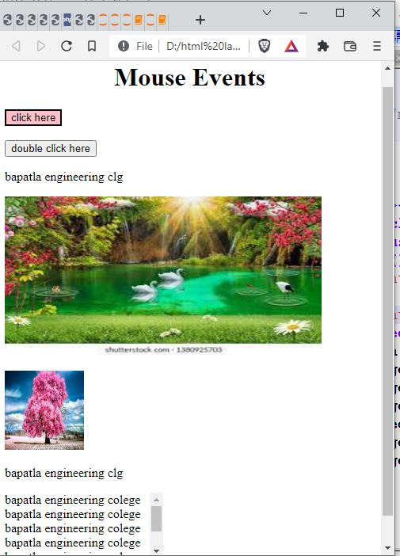

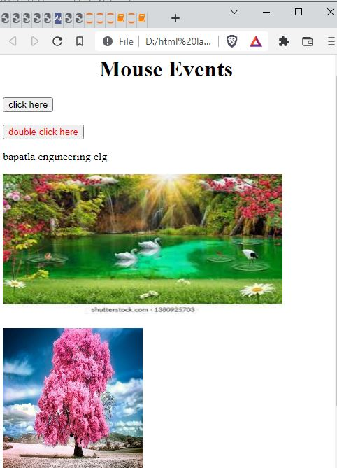

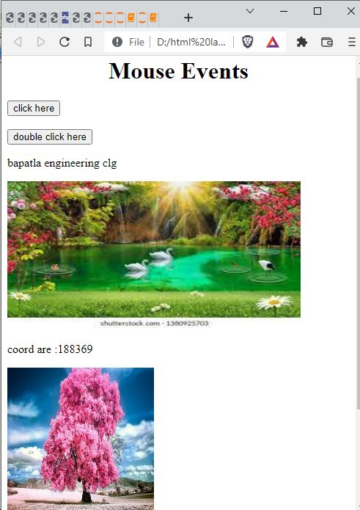

**Aim:-Create a HTML file that demonstrate the popup boxews(alert,confirm and prompt)**

**Source Code*:-***

<!DOCTYPE html>

<html>

<head>

<title>popup boxes</title>

<script type="text/javascript">

var i;

functionalertmsg(){

i=alert("Please enter mandatory fields");

}

functionconfirmmsg(){

i=confirm("do you want to proceed");

document.write(i);

}

functionpromptmsg(){

i=prompt("please enter the OTP");

document.write(i);

}

</script>

</head>

<body>

<H1>popup BOXES</H1>

<button onclick="alertmsg()">Alert Box</button>

<button onclick="confirmmsg()">confirm Box</button>

<button onclick="promptmsg()">prompt Box</button>

</body>

</html>

**OUTPUT:-**

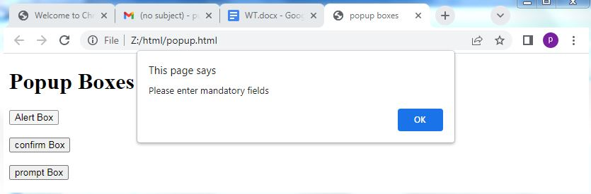

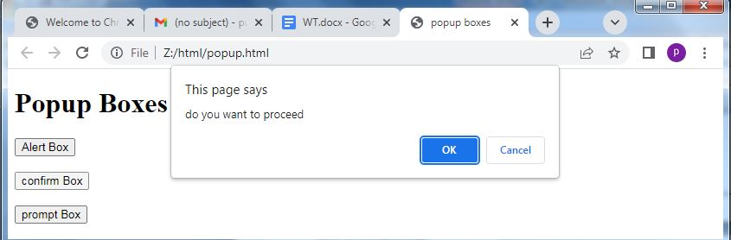

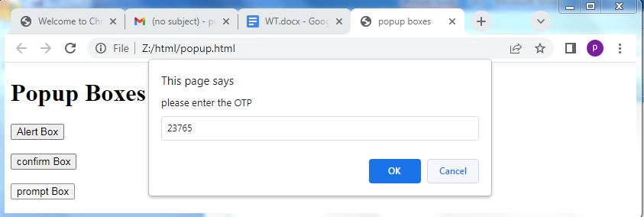

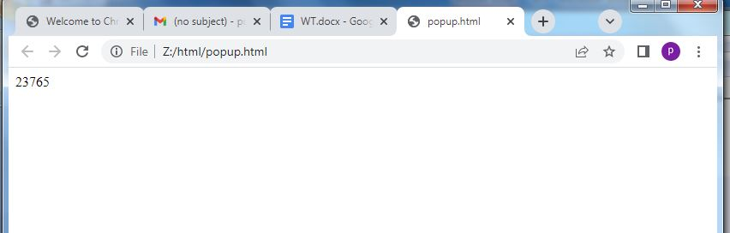

**Aim*:-*Design web page that demonstrate the form events**

**Source Code:-**

<!DOCTYPE html>

<html>

<head>

<title>form events</title>

<script type="text/javascript">

function blur1(){

var x=document.getElementById("f1");

x.value=x.value.toUpperCase();

}

function change1(x){

x.style.color="red";

}

function focus2(y){

y.style.background="yellow";

}

function input1(){

var x=document.getElementById("f3").value;

document.getElementById("demo").innerHTML="you wrote: "+x;

}

function reset1(){

alert("the form was reset");

}

function search1(){

var x=document.getElementById("f4");

document.getElementById("demo1").innerHTML="you searching for: "+x.value;

}

function select1(){

alert("you select some text");

}

function submit1(){

alert("the form was submitted");

}

</script>

</head>

<body>

<h1>Form Events</h1>

ENTER NAME:<input type="text" onblur="blur1()"id="f1">input text change to uppercase after onblur<br><br>

ENTER NAME:<input type="text" onchange="change1(this)" id="f2">change color<br><br>

ENTER NAME:<input type="text" onfocus="focus2(this)">change backgroundcolor when focus the button<br><br>

ENTER NAME:<input type="text" oninput="input1()"id="f3"><br>

<p id="demo"></p>

<form>

NAME:<input type="text" oninvalid="alert('you must fill out the form!');" name="fname" required>

<input type="submit" vaue="submit">

</form>

<form onreset="reset1()">

ENTER NAME:<input type="text">

<input type="reset" value="reset">

</form>

<input type="search" id="f4"onsearch="search1()">

<p id="demo1"></p>

<input type="text" value="hello world!" onselect="select1()">

<form id="f5">

NAME:<input type="text" name="fname" onsubmit="submit1()">

<input type="submit" value="submit">

</form>

</body>

</html>

**OUTPUT:-**

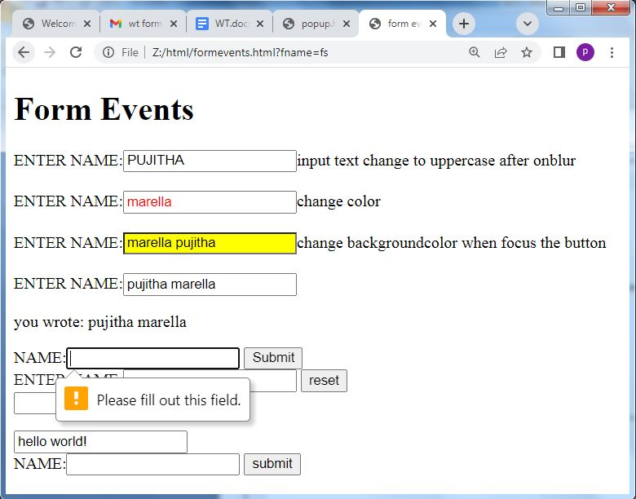

**EXPERIMENT-6**

**Aim:*-*Write a javascript to demonstrate the String object**

**Source Code:-**

<!DOCTYPE HTML>

<html>

<head>

<title>Strings</title>

</head>

<body>

<h1>String objects</h1>

<script type="text/javascript">

var s1="MARella";

var s2="pujitha";

var s3="welcome to javascript";

var s4=["pujitha","Divya","Latha","Suhana"];

var s5=s1.sub();

var s6=s2.sup();

document.write(s1.length+"<br>");

document.write(s1.charAt(3)+"<br>");

document.write(s1.charCodeAt(1)+"<br>");

document.write(s1.concat(s2)+"<br>");

document.write(s3.indexOf("e")+"<br>");

document.write(s3.lastIndexOf("a")+"<br>");

document.write(s2.match("ja")+"<br>");

document.write(s3.replace("to","my")+"<br>");

document.write(s4.slice(0,2)+"<br>");

document.write(s3.slice(9,15)+"<br>");

document.write(s3.split(" ")+"<br>");

document.write(s1.toLowerCase()+"<br>");

document.write(s3.toUpperCase()+"<br>");

document.write(s1.substring(1,5)+"<br>");

document.write(s1.toString()+"<br>");

document.write(s1.valueOf()+"<br>");

alert(s1.anchor("pujitha")+"<br>");

document.write(s3.big()+"<br>");

document.write(s1.blink()+"<br>");

document.write(s2.bold()+"<br>");

document.write(s3.fixed()+"<br>");

document.write(s1.fontcolor("green")+"<br>");

document.write(s1.fontsize("20px")+"<br>");

document.write(s3.italics()+"<br>");

document.write(s3.link("mouse2.html")+"<br>");

document.write(s2.small()+"<br>");

document.write(s2.strike()+"<br>");

document.write(s2+" "+s5+"<br>");

document.write(s1+" "+s6+"<br>");

</script>

</body>

</html>

**OUTPUT:-**

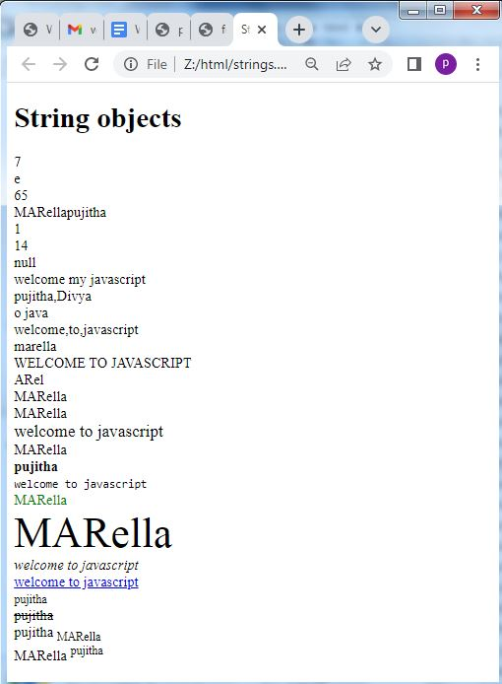

**EXPERIMENT-6**

**Aim:*-*Write a javascript to demonstrate the Math object**

**Source Code:-**

<!DOCTYPE html>

<html>

<head>

<title>math Objects</title>

</head>

<body>

<script type="text/javascript">

document.write("<h2>MATH OBJECT PROPERTIES</h2>");

document.write("euler's numberE:"+Math.E);

document.write("<br>natural logorithm of 2:"+Math.LN2);

document.write("<br>natural logorithm of 10:"+Math.LN10);

document.write("<br>base-10 logarithmic of E :"+Math.LOG10E);

document.write("<br>number value of PI:"+Math.PI);

document.write("<br>square root of 1/2:"+Math.SQRT1_2);

document.write("<br>square root of 2:"+Math.SQRT2);

document.write("<h2>MATH OBJECT METHODS</h2>");

document.write("<br>absolute value of pi"+Math.abs(Math.PI));

document.write("<br>ceil value of 20.2345"+Math.ceil(20.2345));

document.write("<br>natural logrithm of 20:"+Math.log(20));

document.write("<br>max value among(5,6,7,8,9):"+Math.max(5,6,7,8,9));

document.write("<br>min value among(5,6,7,8,9):"+Math.min(5,6,7,8,9));

document.write("<br>the value of 5 to the power of 2:"+Math.pow(5,2));

document.write("<br>random number between 0 and 1:"+Math.random());

document.write("<br>square root of 25:"+Math.sqrt(25));

</script>

</body></html>

**OUTPUT:-**

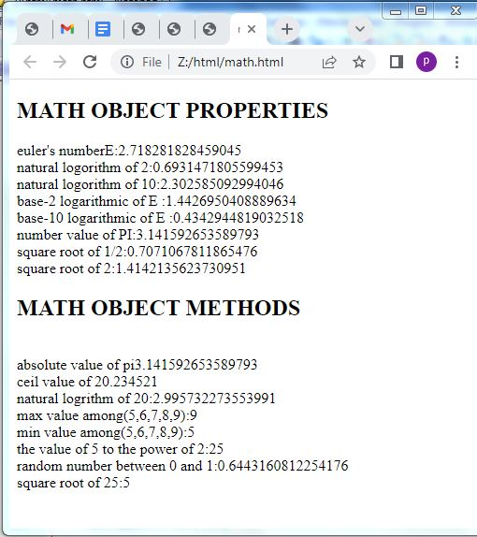

**Aim:*-*Write a javascript to demonstrate the Math object**

**Source Code:-**

<!DOCTYPEhtl>

<html>

<head>

<body>

<script type="text/javascript">

var d1=new Date();

var d2=new Date(200000);

var d3=new Date("july 11,2022");

var d4=new Date(2022,00,01);

var d5=new Date(2022,00,01,10,45,30);

document.write("<h2>Date objects creation</h2>");

document.write("Empty Date object creation:"+d1);

docment.write("<br>Date object will milliseconds:"+d2);

document.write("<br>date object with string:"+d3);

document.write("<br>date object with specified date:"+d4);

document.write("<br>date object with specified date&time:"+d5);

document.write("<h2>Date object method</h2>");

document.write("current date:"+Date(d1.valueOf()));

document.write("<br>Day:"+d1.getDay());

document.write("<br>Date:"+d1.getDate());

document.write("<br>month:"+d1.getMonth());

document.write("<br>Year:"+d1.getFullYear());

document.write("<br>hourse:"+d1.getHours());

document.write("<br>minutes:"+d1.getMinutes());

document.write("<br>seconds:"+d1.getSeconds());

document.write("<br>Milliseconds:"+d1.getMilliseconds());

document.write("<br>Time:"+Date(d1.getTime()));

document.write("<br>difference between UTC time and local time,in minutes:"+d1.getTimezoneOffset());

document.write("<br>setting the date :"+d1.setDate(10));

document.write("<br>getting the date :"+d1.getDate());

</script>

</body>

</html>

**OUTPUT:-**

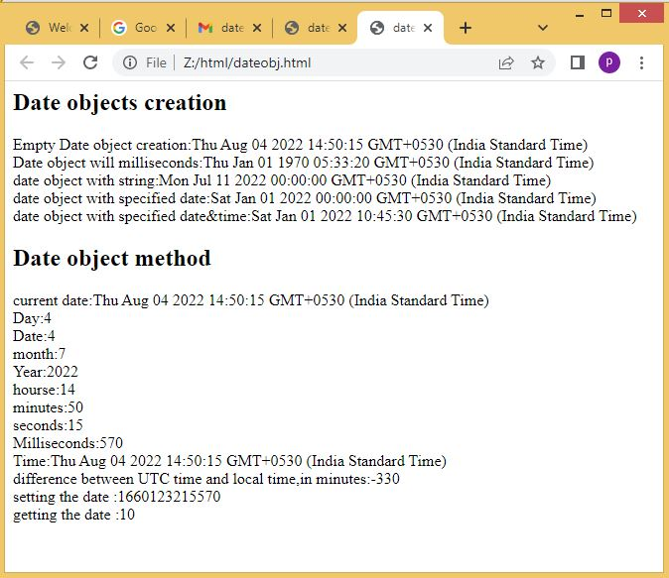

**EXPERIMENT-7**

**Aim:*-*Write a javascript to demonstrate the window object**

**Source Code:*-***

<!DOCTYPE HTML>

<html>

<head>

<title>window objects</title>

</head>

<body>

<h1>Frames</h1>

<iframesrc="p1.html" width="200" height="200"></iframe>

<iframesrc="popup.html" width="200" height="200"></iframe>

<iframesrc="" width="200" height="200"></iframe>

<h1>window object methods</h1>

<button id="btn1" onClick="win=window.open()">Open window </button>

<button id="btn2" onClick="win.close()">close window </button>

<button id="btn3" onClick="window.alert('Alert message')">alert</button>

<button id="btn4" onClick="window.prompt('prompt message')">prompt</button>

<button id="btn5" onClick="window.confirm('confirm message')">confirm</button>

<button id="btn5" onClick="win.moveBy(100,100)">move by window 100,100pixel</button>

<h1>window object properties</h1>

<script type="text/javascript">

document.write("number of frames:"+window.length);

window.frames[2].location="Z://html/css in.html";

document.write("<br>height of the windows content area(viewport)including scrollbars:"+window.innerHeight);

document.write("<br>width of the windows content area(viewport)including scrollbars:"+window.innerWidth);

document.write("<br>height of the browser windows,including toolbar/scrollbars:"+window.outerHeight);

document.write("<br>width of the browser windows,including toolbar/scrollbars:"+window.outerWidth);

</script>

</body>

</html>

**OUTPUT:-**

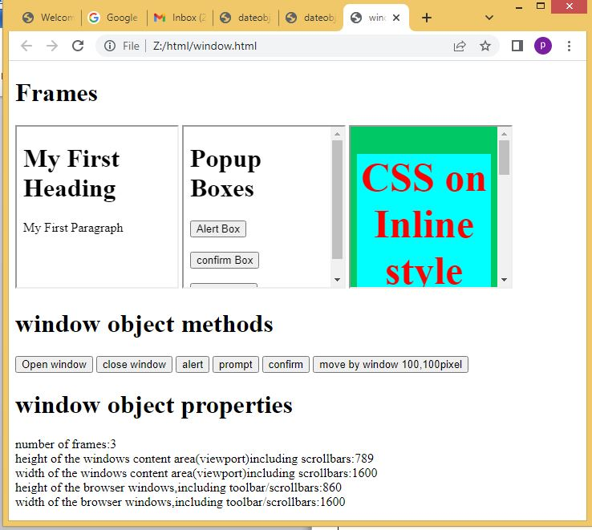

**Aim:*-*Write a javascript to demonstrate the Document object**

**SourceCode:-**

<!DOCTYPE HTML>

<html>

<head>

<title>Document Object</title>

</head>

<body>

<h2>Images</h2>

Iamge1:<img id ="imgl" src="d1.jpg" width="100" height="100">

Iamge2:<img id ="img2" src="d6.jpg" width="100" height="100">

<h2>Links</h2>

<a id="link1" href="mouse.html">Pagel</a>

<a id ="link2" href="formev.html">Page2</a>

<h2>Docuemnt object methods</h2>

<button onclick="open_doc()">Open Docuemnt</button>

<script type="text/javascript">

document.write("<h2>Document object collection</h2>");

document.write("Number of images:"+document.images.length);

document.write("<br>Number of links:"+document.links.length);

document.write("<h2>Document object properties</h2>");

document.write("Title of docuemnt:"+document.title);

document.write("<br>URL of docuemnt:"+document.URL);

document.write("<br> state of docuemnt:"+document.readyState);

document.write("<br>lastmodified of docuemnt:"+document.lastModified);

functionopen_doc(){

varmywindow = window.open();

mywindow.document.open();

mywindow.document.write("<h1>Welcome to document</h1>");

mywindow.document.close();

}

</script>

</body>

</html>

**OUTPUT:-**



**EXPERIMENT-8**

**Aim:- write a Javascript program to demonstrate the following operations using DOM**

**1)Create Element 2)Remove element 3)Duplicate Element 4)Insert the element before**

**Source Code:-**

<!Doctype html>

<html>

<head>

<title>Node Interface</title>

<script type="text/javascript">

functioncreate_node(){

var link=document.createElement("a");

link.setAttribute("id","l1");

link.setAttribute("href","Z://WT LAB/popup.html");

link.setAttribute("width","100");

link.setAttribute("height","100");

text=document.createTextNode("My link");

link.appendChild(text)

document.body.appendChild(link);

}

functiondelete_node()

{

child=document.getElementById("l1");

document.body.removeChild(child);

}

function clone_node()

{

link=document.getElementById("l1");

c=link.cloneNode(true);

document.body.appendChild(c);

}

Function insert_node()

{

link=document.getElementById("l1");

para=document.createElement("p");

para.setAttribute("id","p1");

text=document.createTextNode("My Paragraph before link");

para.appendChild(text);

document.body.insertBefore(para,link)

}

</script>

</head>

<body>

<div id="id">

<h2>Node Interface Methods</h2>

<button onclick="create_node()">Create Link</button>

<button onclick="delete_node()">Remove Link</button>

<button onclick="clone_node()">Clone Link</button>

<button onclick="insert_node()">Insert paragraph before Link</button>

</div>

</body>

</html>

**OUTPUT:-**

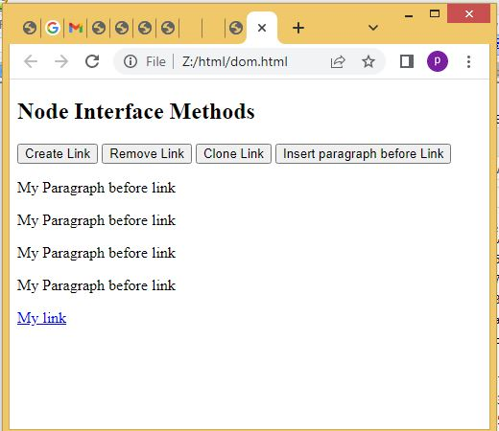

**EXPERIMENT-8**

**Aim:-Develop a simple calculator web application using HTML,CSS,JS**

**Source Code:-**

<!DOCTYPE html>

<html>

<head>

<script type="text/javascript">

function dis(val)

{

document.getElementById("result").value+=val

}

function solve()

{

var x = document.getElementById("result").value

var y = eval(x)

document.getElementById("result").value = y

}

function clr()

{

document.getElementById("result").value = ""

}

</script>

</head>

<body>

<h1>Calculator</h1>

<table border="2" style="border-collapse:collapse">

<tr>

<td colspan="3"><input type="text" id="result" style="text-align:right">

<td><input type="button" value="c" onclick="clr()"/></td>

</tr>

<tr>

<td><input type="button" value="1" onclick="dis('1')"/></td>

<td><input type="button" value="2" onclick="dis('2')"/></td>

<td><input type="button" value="3" onclick="dis('3')"/></td>

<td><input type="button" value="/" onclick="dis('/')"/></td>

</tr>

<tr>

<td><input type="button" value="4" onclick="dis('4')"/></td>

<td><input type="button" value="5" onclick="dis('5')"/></td>

<td><input type="button" value="6" onclick="dis('6')"/></td>

<td><input type="button" value="-" onclick="dis('-')"/></td>

</tr>

<tr>

<td><input type="button" value="7" onclick="dis('7')"/></td>

<td><input type="button" value="8" onclick="dis('8')"/></td>

<td><input type="button" value="9" onclick="dis('9')"/></td>

<td><input type="button" value="+" onclick="dis('+')"/></td>

</tr>

<tr>

<td><input type="button" value="." onclick="dis('.')"/></td>

<td><input type="button" value="0" onclick="dis('0')"/></td>

<td><input type="button" value="=" onclick="solve()" style="background-color:blue;color:red"/></td>

<td><input type="button" value="*" onclick="dis('*')"/></td>

</tr>

</table>

</body>

**OUTPUT:-**

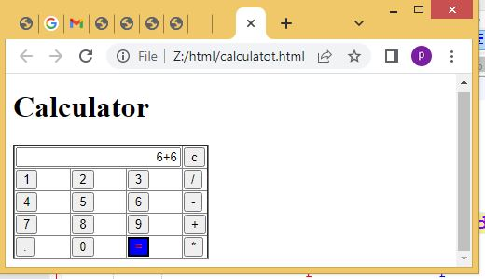

**EXPERIMENT-9**

**Aim:- Write an inline DTD**

**Source Code:-**

<?xml version="1.0" encoding="UTF-8"?>

<!DOCTYPE student[

<!ELEMENT student (name,regd,address)>

<!ELEMENT name (#PCDATA)>

<!ELEMENT address (dno,street,city)>

<!ELEMENTdno (#PCDATA)>

<!ELEMENT street (#PCDATA)>

<!ELEMENT city (#PCDATA)>

]>

<student>

<name>Apple</name>

<regd id="401"/>

<address>

<dno>5-2</dno>

<street>old bus stand</street>

<city>bapatla</city>

</address>

</student>

**OUTPUT:-**

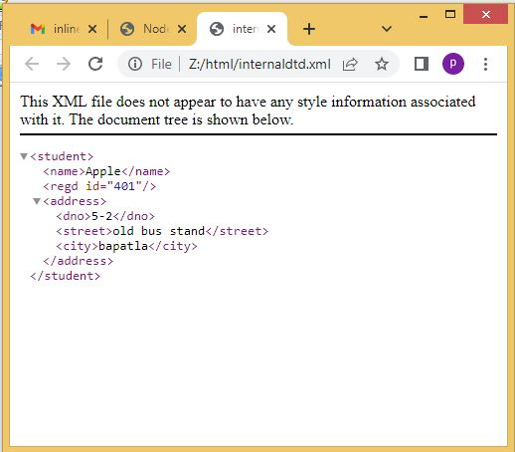

**Aim:- Write an external DTD**

**Source Code:-**

<?xml version="1.0" encoding="UTF-8"?>

<!DOCTYPE student SYSTEM "stu.dtd">

<student>

<name>Apple</name>

<regd id="401"/>

<address>

<dno>5-2</dno>

<street>old bus stand</street>

<city>bapatla</city>

</address>

</student>

**Stu.dtd:-**

<!ELEMENT student (name,regd,address)>

<!ELEMENT name (#PCDATA)>

<!ELEMENT address (dno,street,city)>

<!ELEMENTdno (#PCDATA)>

<!ELEMENT street (#PCDATA)>

<!ELEMENT city (#PCDATA)>

**OUTPUT:-**

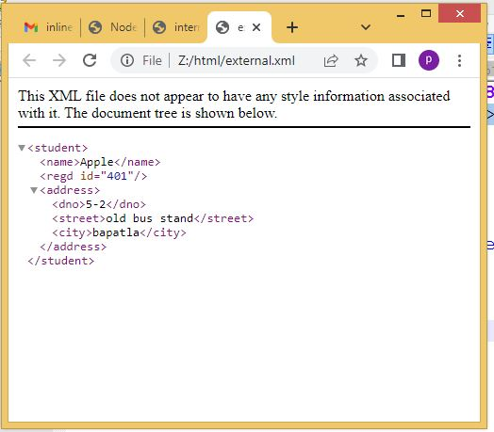

**Aim:- Create an XML file to store the student name and register number validate with XSD**

**Source Code:-**

**Stu.xsd:-**

<?xml version="1.0"?>

<xs:schemaxmlns:xs="http:\\www.w3.org\2001\xmlschema">

<xs:element name="student">

<xs:complexType>

<xs:sequence>

<xs:element name="name" type="xs:string"/>

<xs:element name="regd" type="xs:string"/>

</xs:sequence>

<xs:attribute name="branch"type="xs:string"/>

</xs:complexType>

</xs:element>

</xs:schema>

**stu.xml:-**

<?xml version="1.0"?>

<student branch="it">

<name>apple</name>

<regd>y20ait467</regd>

</student>

**OUTPUT:-**

